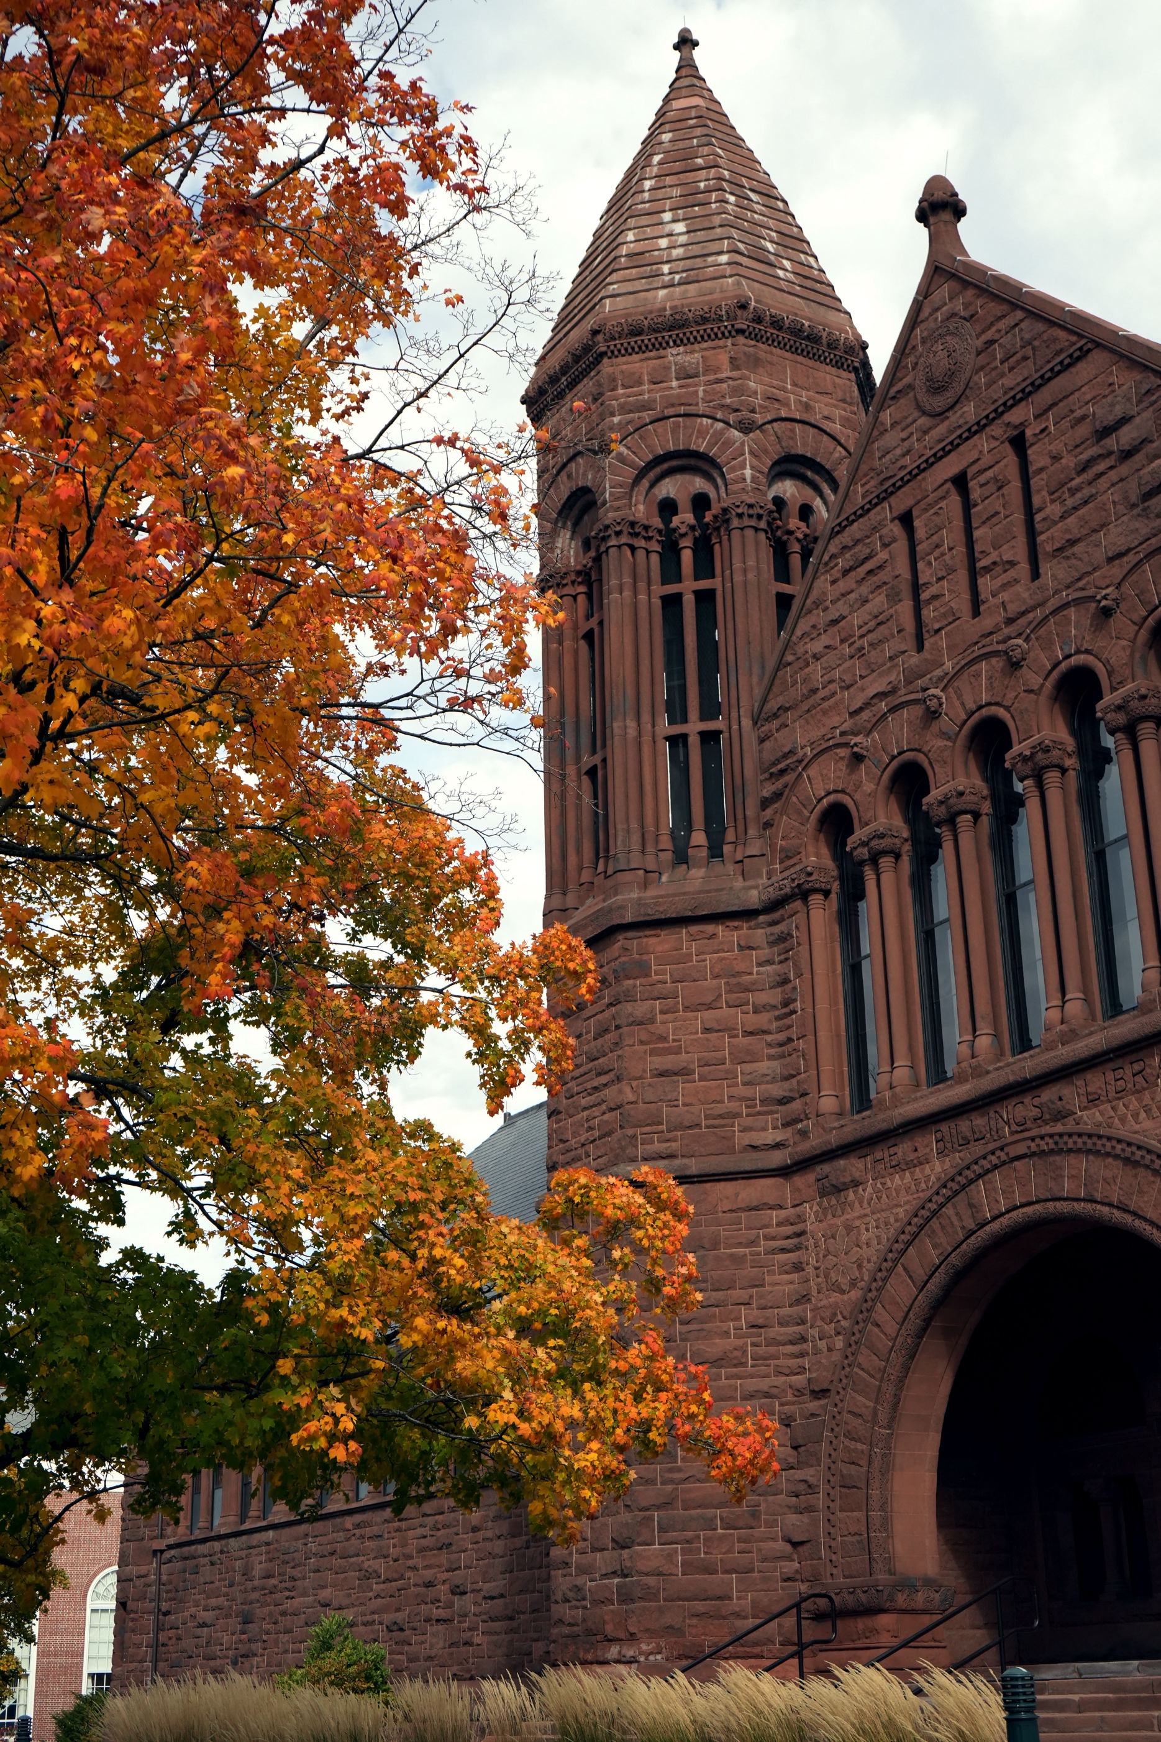

THE GROSSMAN DEAN’S CUP CASE COMPETITION
HANDBOOK
GUIDELINES, RULES, AND EXPECTATIONS

OVERVIEW
The Dean’s Cup is a two-round, single day case competition designed for undergraduate students to test their analytical, strategic, and presentation skills. Teams of two to four students will analyze a business case and present their recommendations to a panel of judges comprising of The Grossman School of Business professors and industry professionals.

The case is released three weeks before the competition, allowing teams ample time to prepare. Each team has 15 minutes to present their analysis and recommendations, followed by a 10-minute Q&A with the judges. Judges then provide five minutes of direct feedback after each presentation. Teams are expected to present in business professional attire, with polished and professional slides. The competition has two rounds: an opening round (morning of the competition) and a final round (afternoon of the competition day). Judges will assess which teams move into the final round.

Participation is open exclusively to full-time undergraduate students. Invited universities may register one team and will need to have a faculty advisor who can be present with them on the day of the competition. Students are allowed to compete in multiple years of competition.

ROLES
COMPETITORS
Students from the University of Vermont can register as a part of a team or as an individual and will be assigned to a team by the Dean’s Cup Student Committee. Only current undergraduate-level students are eligible to compete.

Students from invited universities must be registered by a faculty advisor. Only currently enrolled undergraduate students during the semester of the competition are eligible to compete.

JUDGES
Each judging panel will comprise a mix of GSB professors, industry professionals, and other community members chosen by the Dean’s Cup Student Committee. Judges must attend a virtual orientation and read the assigned case prior to the competition. During the presentations, judges are expected to listen to each 15-minute presentation and ask clarifying questions during the 10-minute Q&A period with the aim of facilitating the professional development of students. After the first round, judges will have time to select teams who will compete in the final round. Judges will use a scoring rubric to assist in making their final decision. Additional information regarding judging criteria can be found below.

FACULTY ADVISOR (External Universities Only)
Invited universities are asked to have a designed faculty/staff advisor to serve as a liaison between their undergraduate team and the Dean’s Cup Student Committee to ensure students will have transportation to and from the competition. Faculty/staff advisors can act as a resource for their teams up to the release of the case. Once the case has been released, students cannot seek assistance from others outside their team on the case up until and on the day of the competition.

Faculty/staff advisors are encouraged to observe any presentation on the day of the competition but are not permitted to seek direct feedback from any judge. Faculty/staff advisors are not permitted to communicate with their team before they present.

OBSERVERS
Competitors, coaches, judges, or organizers may invite observers to attend presentations. Observers may take notes during presentations but must refrain from using electronic devices or causing any distraction.

Faculty advisors may watch any presentation.

Competitors will not be permitted to watch other presentations until the final round, when they are able to watch other finalist presentations after they have presented.

RULES
Dean’s Cup rules are designed to maintain fairness and integrity of the competition for all participants. Any violation thereof may result in disqualification of the team or individual from the event.

COMPETITION FORMAT

Round 1 (Divisions)
Teams receive the case approximately three weeks before the competition. Each team will prepare and submit their presentation slides in advance.

Each presentation is allocated 15 minutes, followed by 10 minutes of Q&A with the judging panel. Teams are not required to use the full 15 minutes. When the team finishes presenting during the 15-minute presentation time, the room coordinator will begin the 10-minute Q&A time. Judges will then provide 5 minutes of feedback immediately after the Q&A. All teams will present in this round.

Teams must submit their final Microsoft PowerPoint (.pptx) presentation file to the organizers approximately 10 days prior to the competition. On competition day, all teams must be onsite by 8:30 a.m. to sign-in.

Round 2 (Finals)
Top-performing teams from the Opening Round advance to the Finals Round, which happens on the afternoon of the day of the competition. Preparation and presentation format are the same as Round 1. Winners are selected based on performance in the Final Round.

Division Structure
The Dean’s Cup Student Committee reserves the right to structure the divisions as they see fit to guarantee fairness to all competing teams.

CONDUCT & PARTICIPATION

AI Policy
Tools such as ChatGPT are permitted. Excessive reliance, however, may result in a perceived lack of originality and could affect judging outcomes.

Team Independence
Teams must work independently. Collaboration between teams is prohibited.

School Anonymity
To ensure a level playing field and maintain fairness for all participants, we ask that you keep your school identity anonymous during the presentation and in your attire. This helps create a neutral environment during competition rounds. In exchange, the organizing committee will do their best to ensure judges are not familiar with competitors prior to the competition.

Dress Code
Business professional attire is required.

Slides
Presentations must be clear, professional, and well-formatted.

Professionalism
Courteous, respectful conduct is always expected.

Technology
Laptops and clickers may be used during presentations. Any special tech needs must be communicated in advance.

Scoring
Judges will use a scoring rubric to guide decisions.

External Aid
Competitors cannot seek help from current or former employees of the company associated with the case nor from any faculty member (including any faculty advisor if applicable).

JUDGING
Judging Selection
Judges are invited and selected by the Dean’s Cup organizing committee. Each judging panel will be comprised of 3–5 judges representing a diverse mix of academics, industry professionals, and community members.

Organizers will take steps to avoid conflicts of interest in the judging panels. If any participant perceives a conflict, they must alert the organizers prior to the start of presentations.

Teams will present to different judging panels as the competition progresses.

Judge Orientation & Training
Prior to observing student presentations, judges will undergo an orientation session to familiarize them with the Dean’s Cup mission, values, roles, operations, and rules.

Judging Criteria
Judges will evaluate teams based on the following items to provide constructive feedback that supports student development:

Problem Identification
- Clarity in distinguishing core issues from symptoms
- Effective clustering of related problems
Analysis
- Balanced use of quantitative and qualitative methods
- Understanding of the broader business system
- Consideration of competitive and cultural context
- Logical and explicit assumptions
Alternatives
- Clear articulation of alternatives
- Appropriateness and consistency with the case situation
- Comparative evaluation of options
Recommendations
- Directly supported by analysis
- Justified with industry and business context
- Both practical and innovative
Implementation Plan
- Specific details of who, what, how, and when
- Clear timeline and accountability
- Contingency or “Plan B”
Presentation Skills
- Professional delivery and polished slides
- Clear and engaging structure
- Effective pacing and time management
- Strong opening and closing
Question & Answer Session
- Succinct, confident responses
- Ability to defend recommendations effectively
- Team consistency in responses
Teamwork
- Engagement of all members
- Supportive interaction among team members
- Cohesive and consistent group performance

Scoring
- All judging panels in the preliminary rounds are required to rank the presenting teams ordinally.
  - Judges are not permitted to award the same rank to teams resulting in a tie.
- The highest-ranked team in a division will move on to finals.
- The highest-ranked team in finals wins the Dean’s Cup.

AWARDS
The top scoring team will receive the Dean’s Cup and each team member will receive a cash prize of $350.

The second and third place teams will receive a medal and individual cash prizes of $250 and $150, respectively.

Best presenters from each division will also be announced following the preliminary round. An overall best presenter will be announced following the finals round, and the winner will receive a $100 prize and a medal.

PRACTICALITIES
Meals
Meals are included with registration. Allergies and dietary information are requested in advance so the organizing team may accommodate participants’ needs.

Travel and Accomodation
Teams and Judges are responsible for their travel and accommodation expenses.

Media Release
By participating in the Dean’s Cup in any capacity, participants understand that they are giving implicit consent to the Grossman School of Business and the University of Vermont to photograph, video tape, audio tape, quote, and/or use the participant's name, without any compensation for use in promotional materials and other media.

Recommended Attire
Competitors must be in “Business Professional” attire for the entirety of the event. Judges may choose to wear ‘Business Professional’ or ‘Business Casual’ attire.

We thank you for your support of The Dean’s Cup as we expand into a larger competition.

With best wishes!
Dean’s Cup Student Committee

